

J. ADAMS & CO EXPANDS THEIR SPOT PRO SERIES

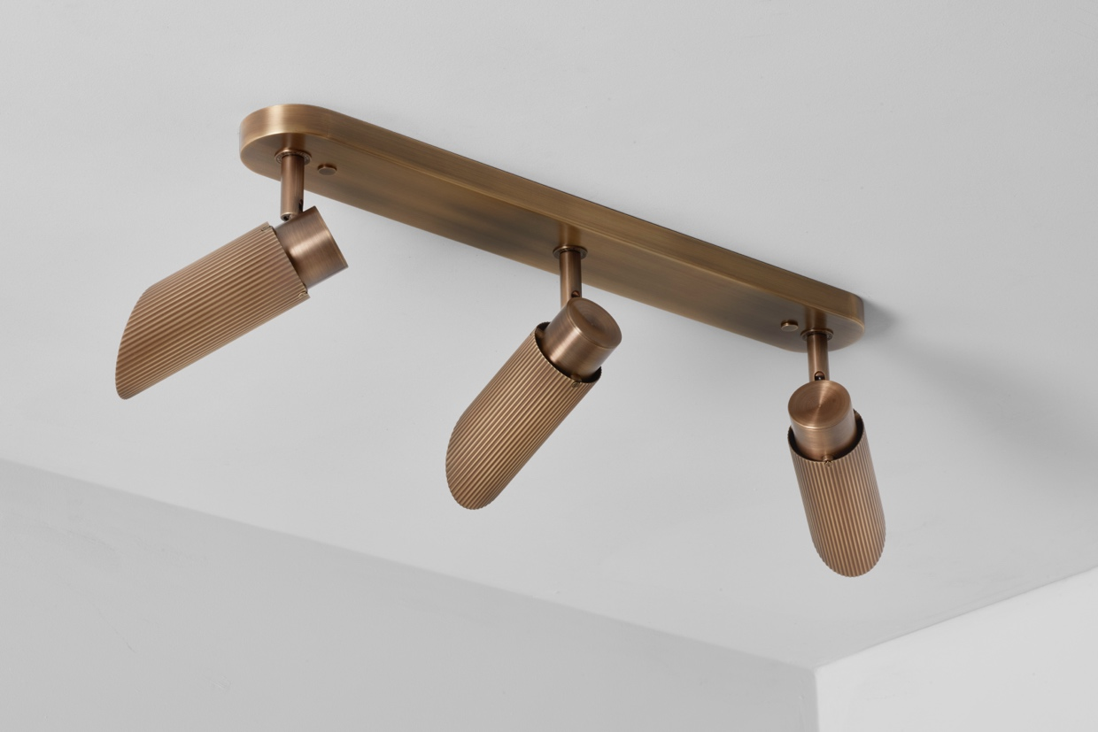

J. Adams & Co is thrilled to announce the launch of the Spot Pro Triple, the latest addition to their esteemed Spot Pro collection. This innovative ceiling light continues the tradition of excellence that defines the Spot Pro series, offering enhanced performance and sleek design for contemporary settings.

Seamlessly blending elegance with functionality, our Spot Pro collection is designed to deliver powerful, professional-grade illumination. Each luminaire in this range offers exceptional performance through high CRI vivid colour rendition technology and versatility with various beam angles.

The Spot Pro Triple is brilliantly engineered to deliver powerful and consistent illumination. Each of its three heads can be independently moved and angled, directing light precisely where you need it. This flexibility is perfect for accentuating specific areas or creating a dynamic lighting environment.

Its innovative design also features recessed LEDs and angled shades, enhancing the sleek, modern aesthetic while significantly reducing glare.

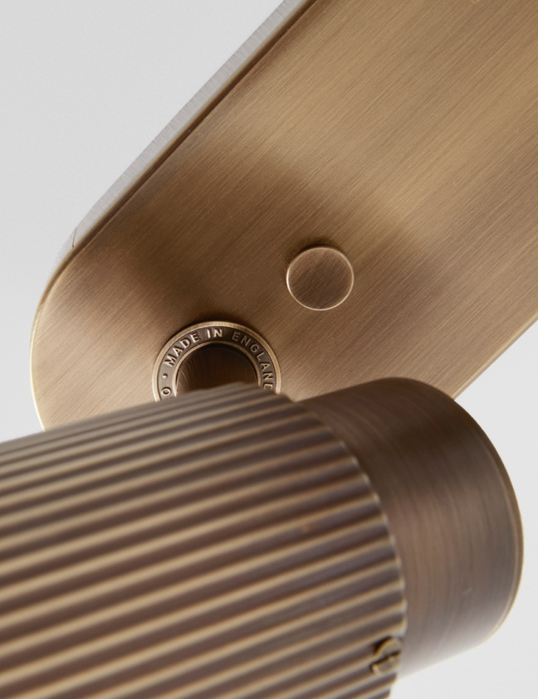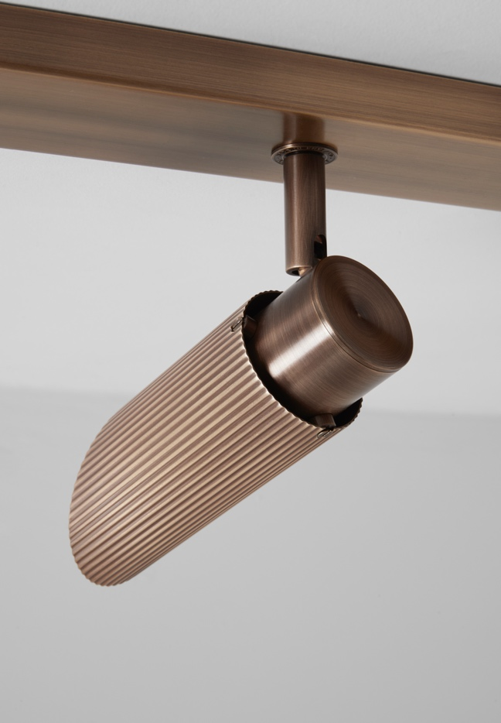

For high resolution imagery, videos, prices and product loans, please contact press@jadamsandco.com

Notes to Editors:
J. Adams & Co is a British lighting manufacturer that specialises in elegant luminaires of unparalleled quality. Handmade in the UK, their Birmingham factory has over half a century of manufacturing and metalworking expertise. The brand seamlessly melds traditional techniques with a nuanced, modern sensibility, focusing on craftsmanship and longevity. The result: refined and contemporary lighting that is built to last.



